**ASSIGNMENT NO. 2**

* DML Operation

1. Change salary of employee 115 to 8000 if the existing salary is less than 6000.

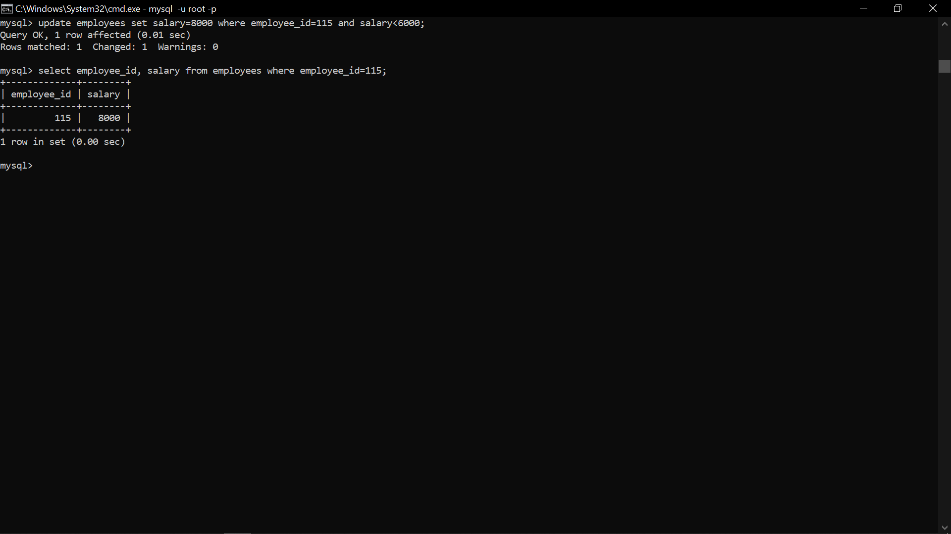

2. Insert a new employee into employees with all the required details.

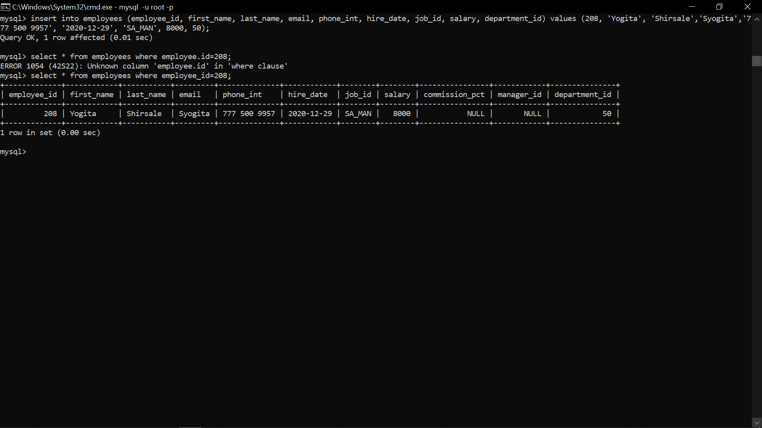

3. Delete department 20.



4. Change job ID of employee 110 to IT_PROG if the employee belongs to department 10 and the existing job ID does not start with IT.

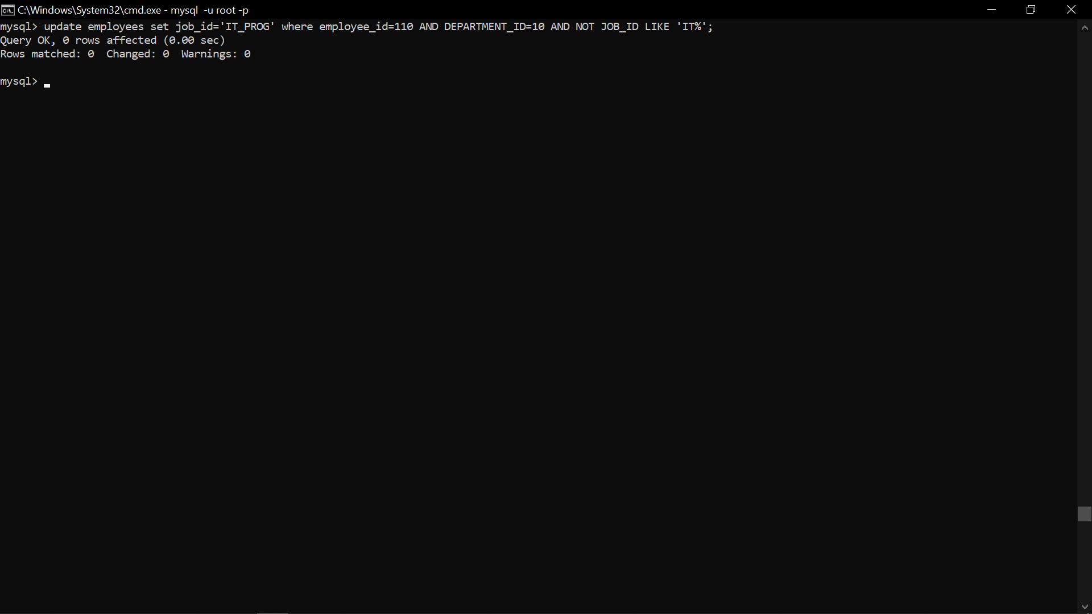

5. Insert a row into departments table with manager ID 120 and location ID in any location ID for city Tokyo.

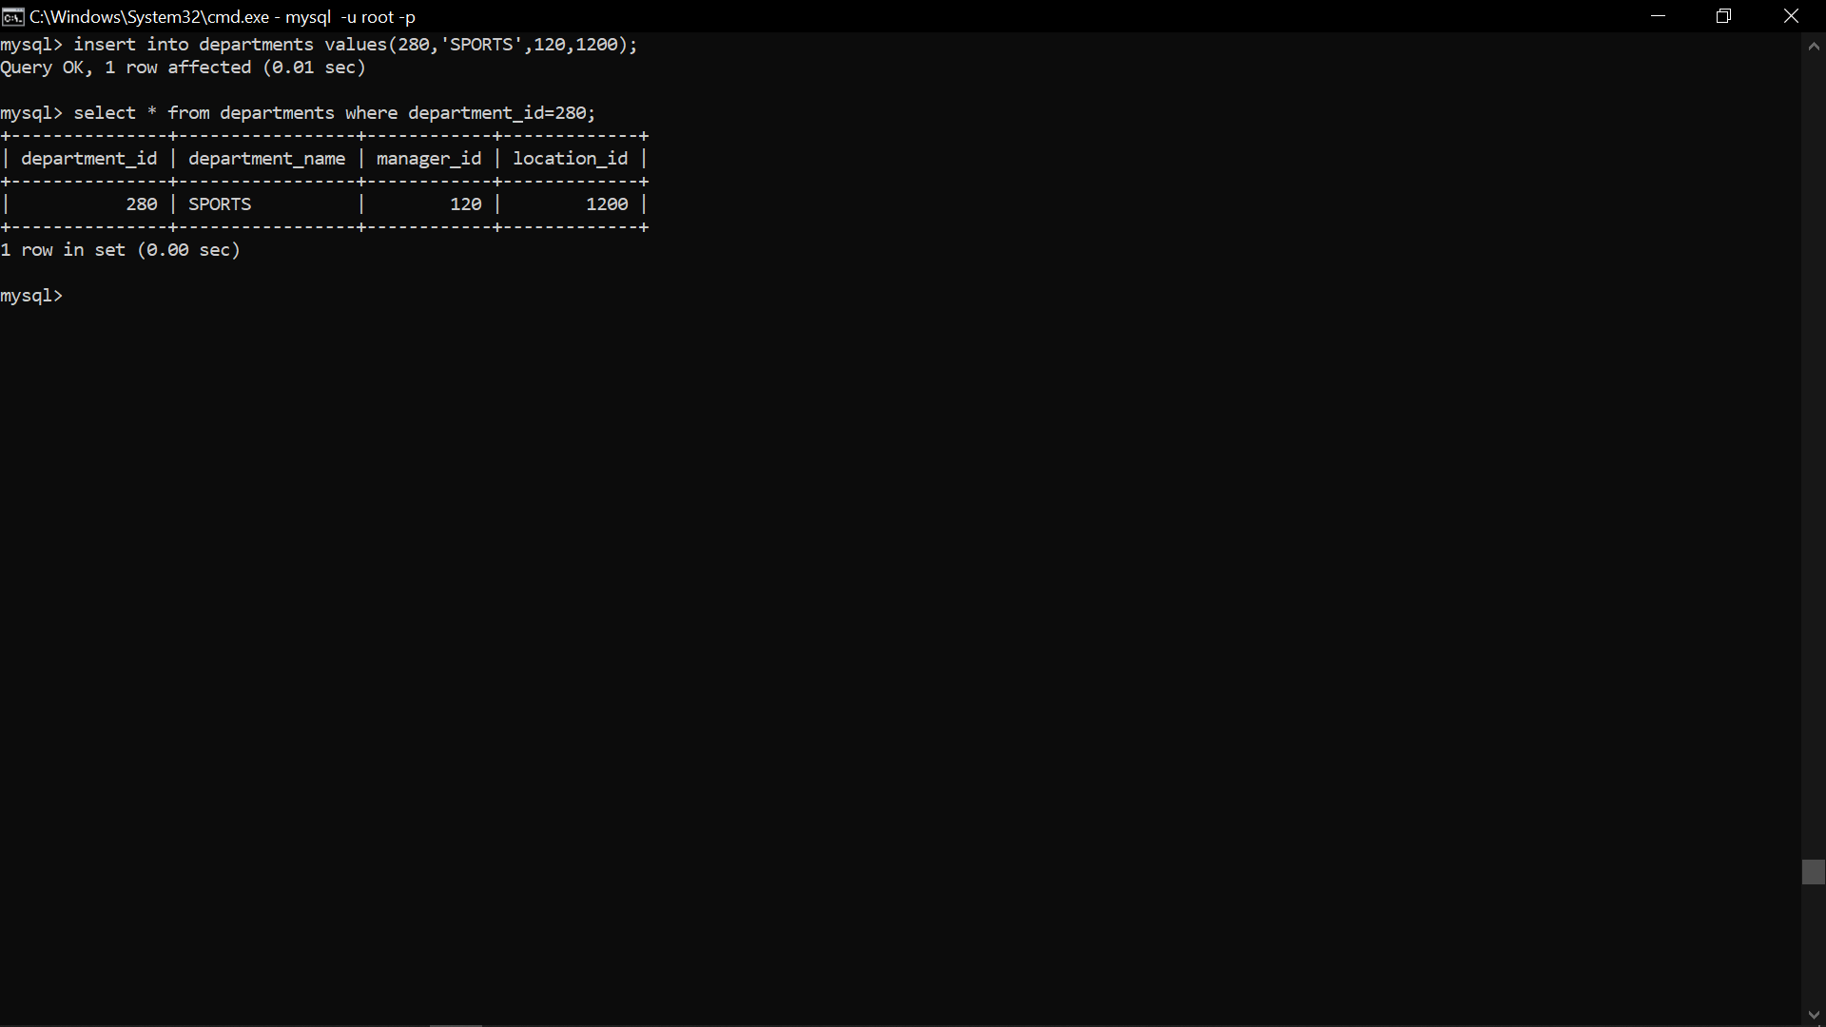

6. Display job title, employee ID, number of days between ending date and starting date for all jobs in department 30 from job history.

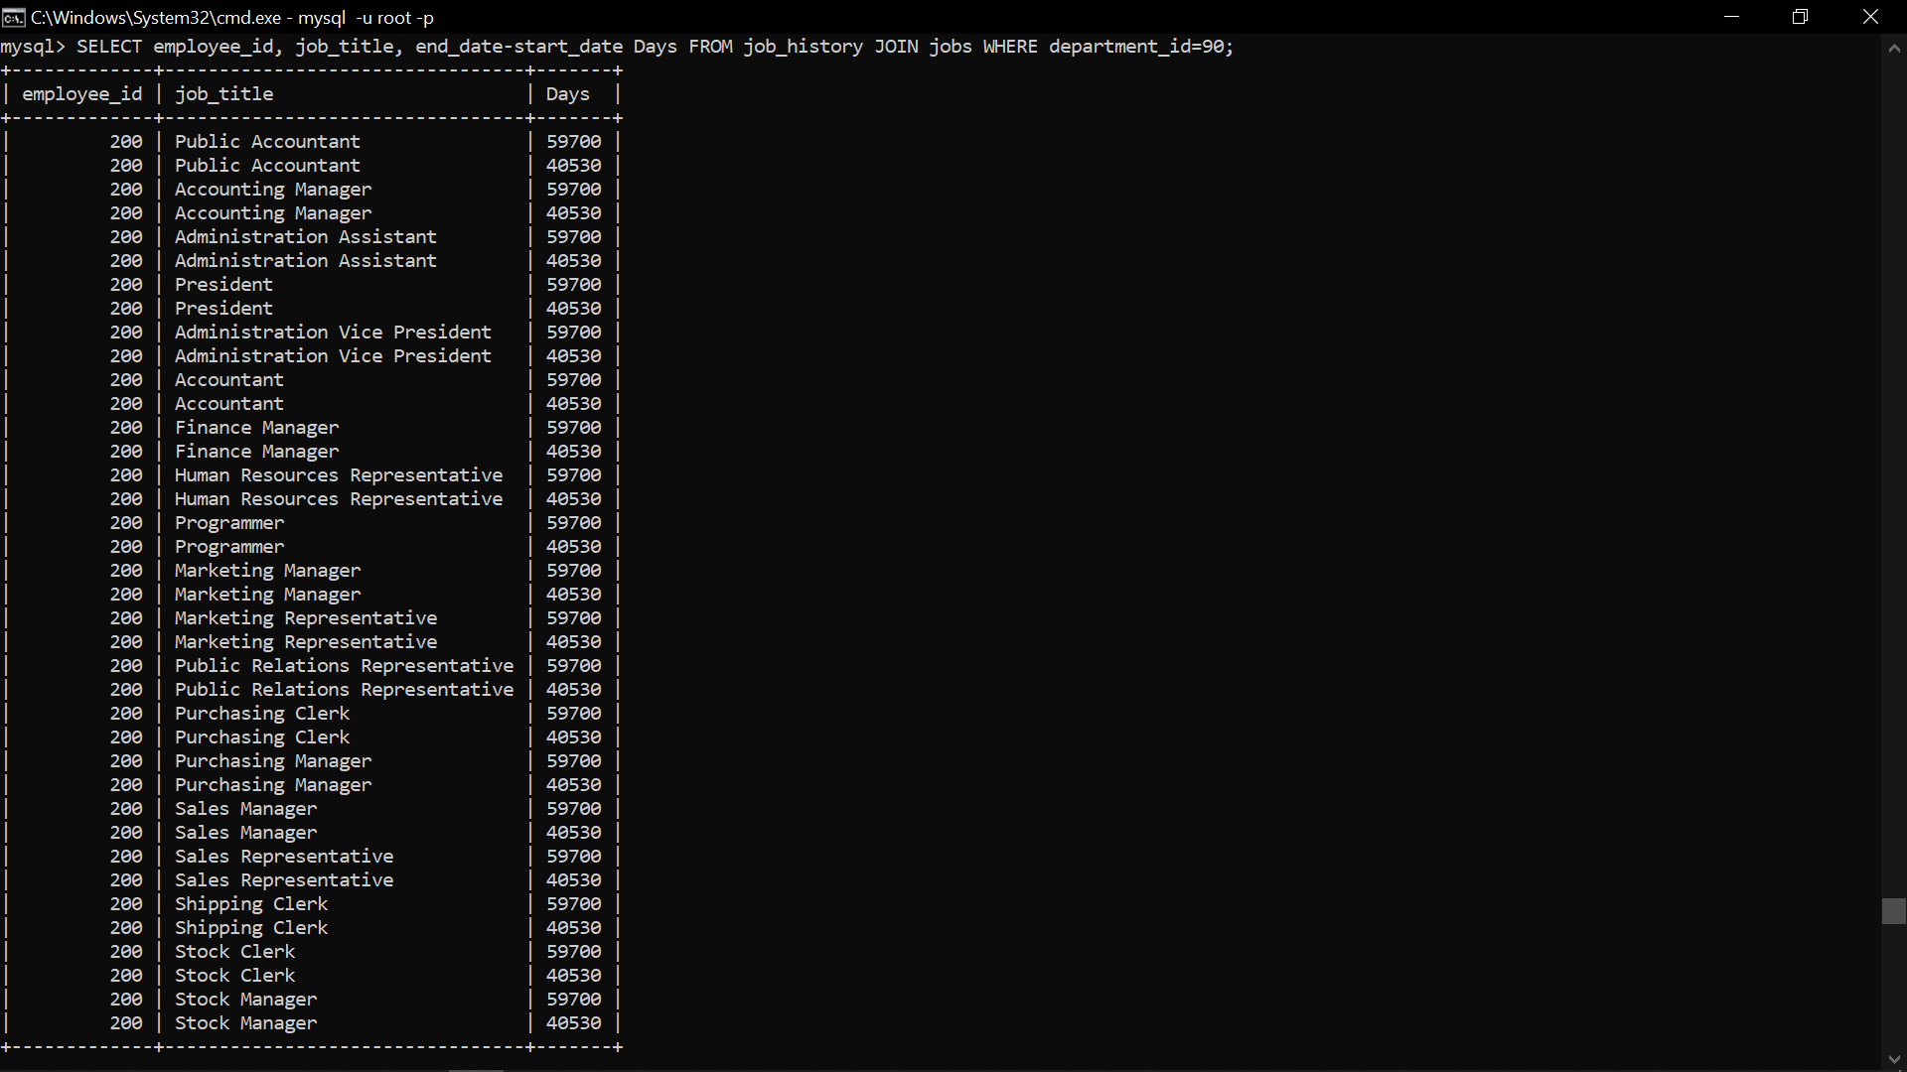

* **DDL Assignments with Constraints**

Table ---> Customer

custId, firstName,lastName,age,city, mobileNumber, dob

Add the Constraints

custId is Primary Key

firstName not null

mobile must be unique

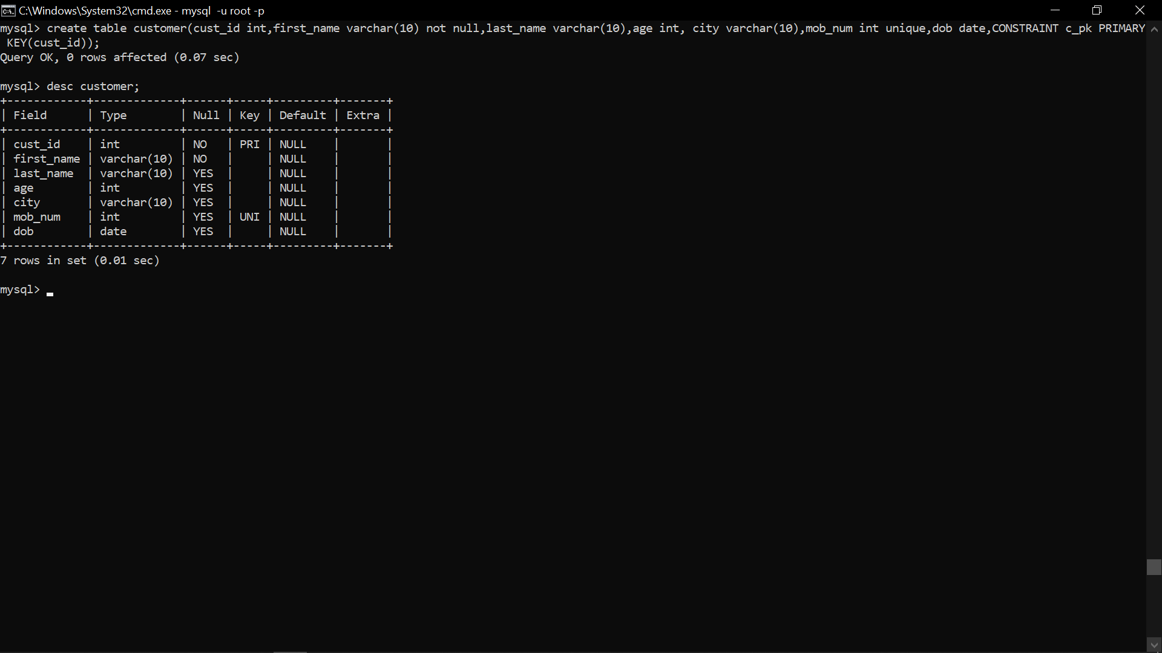

Table ----> Branch

Branch Id, branch Name, city

Add the Constraints

Branch Id is Primary Key

branch Name not null

city not null

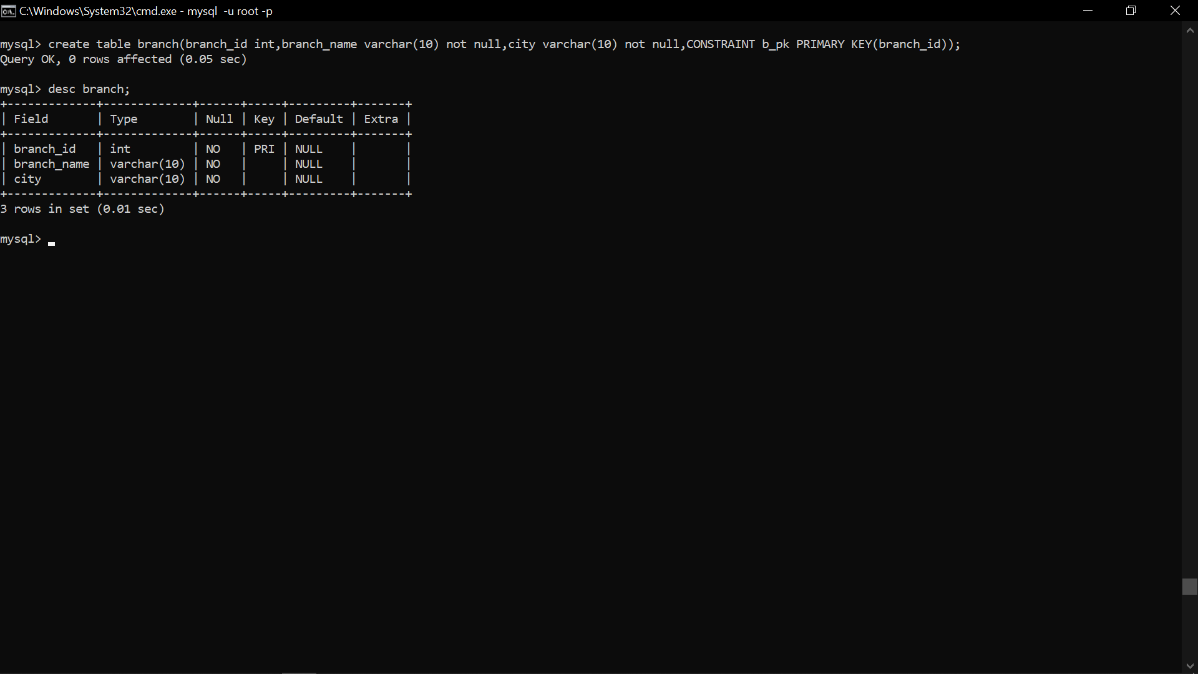

Table -----> Account

Account Number, opening Balance, type Of Account, status ,Bank Id ,Cust Id

Add the Constraints

Account Number is primary key

Opening Balance must be greater than 5000

Type Of Account must be saving/current

Bank Id is foreign key refer to Branch Id(Primary key) Branch table

Cust Id is foreign key refer to Customer(Primary key) Customer table

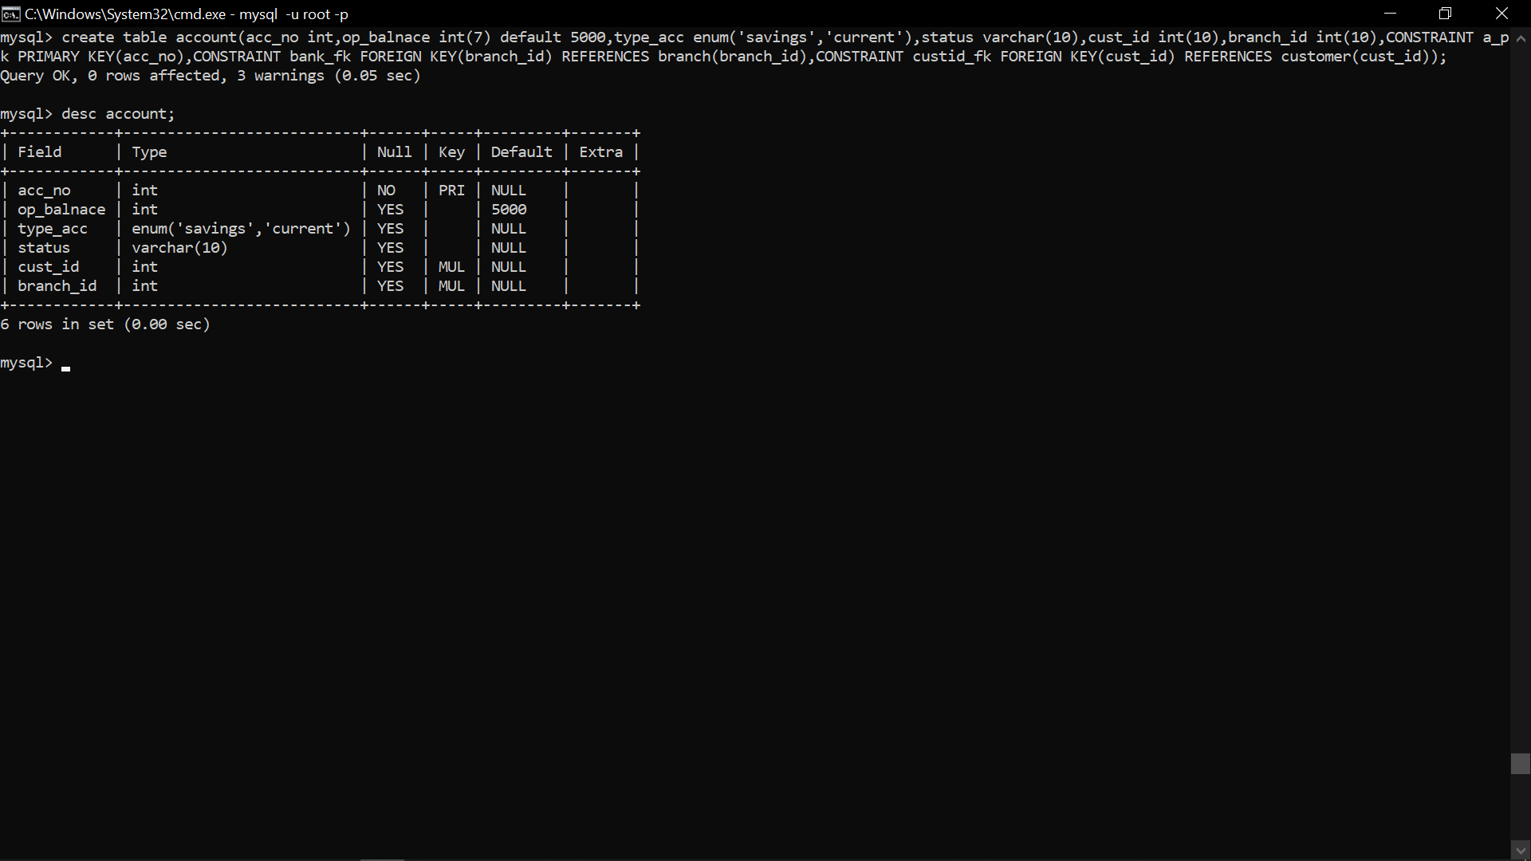

Table ----> Transaction

Transaction Id, transaction Date, Medium Of Transaction, Transaction Amount

Add the Constraints

Transaction Id is primary key

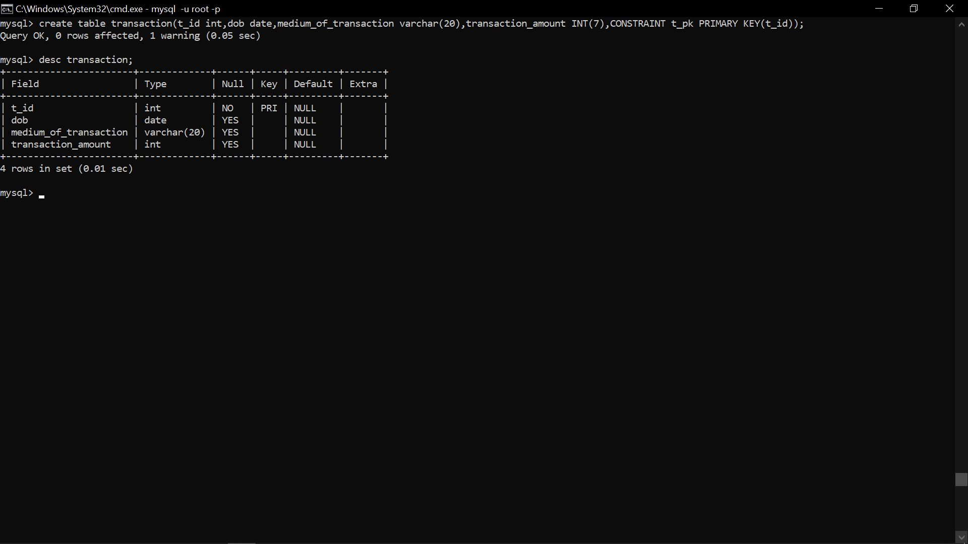

Table ----> Loan

Loan Id, loan Amount, customer Id and bank Id

Add the Constraints

Load Id is primary key

Loan Amount must be + ve

Bank Id is foreign key refer to Branch Id(Primary key) Branch table

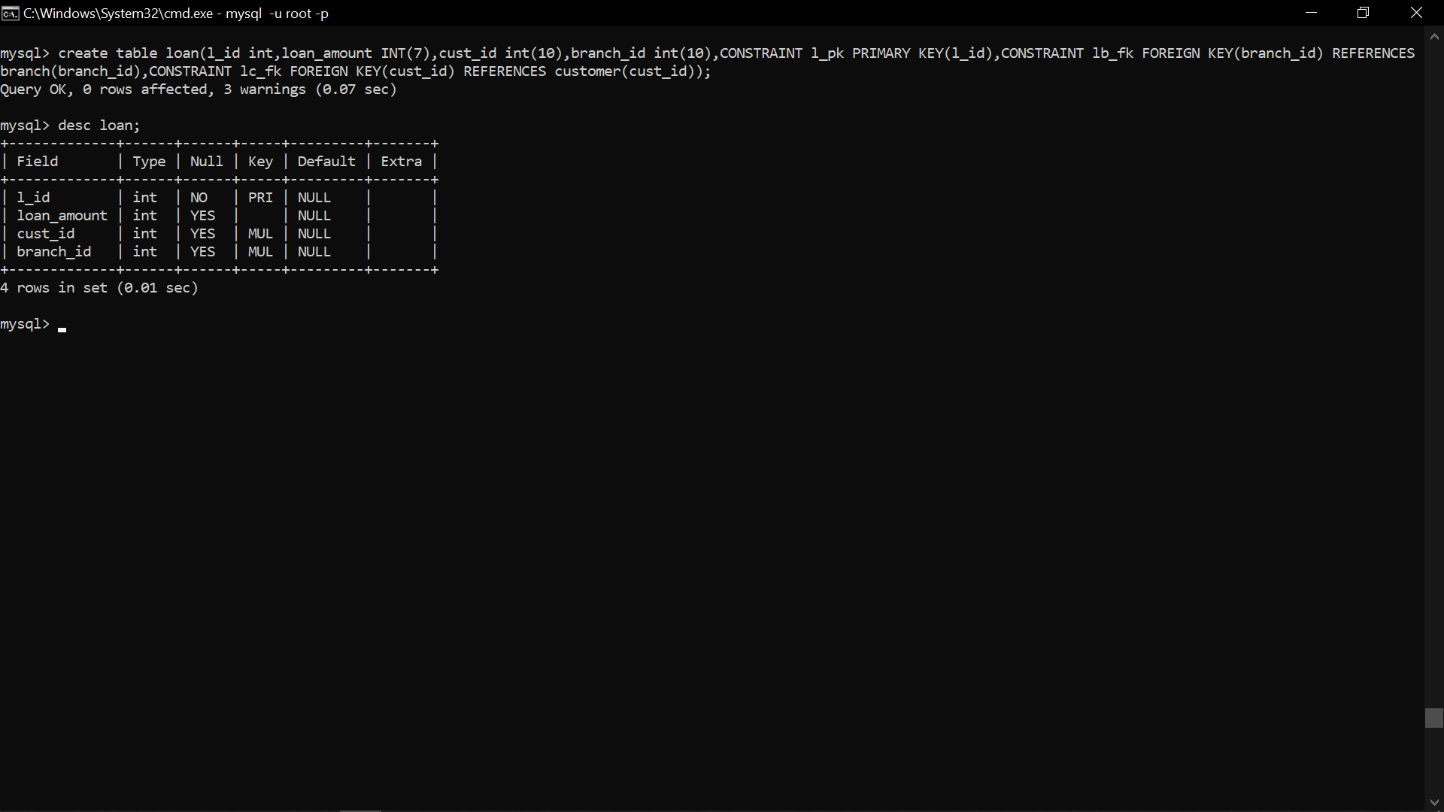

* **Sub Query**

1. Display details of departments managed by ‘John’.

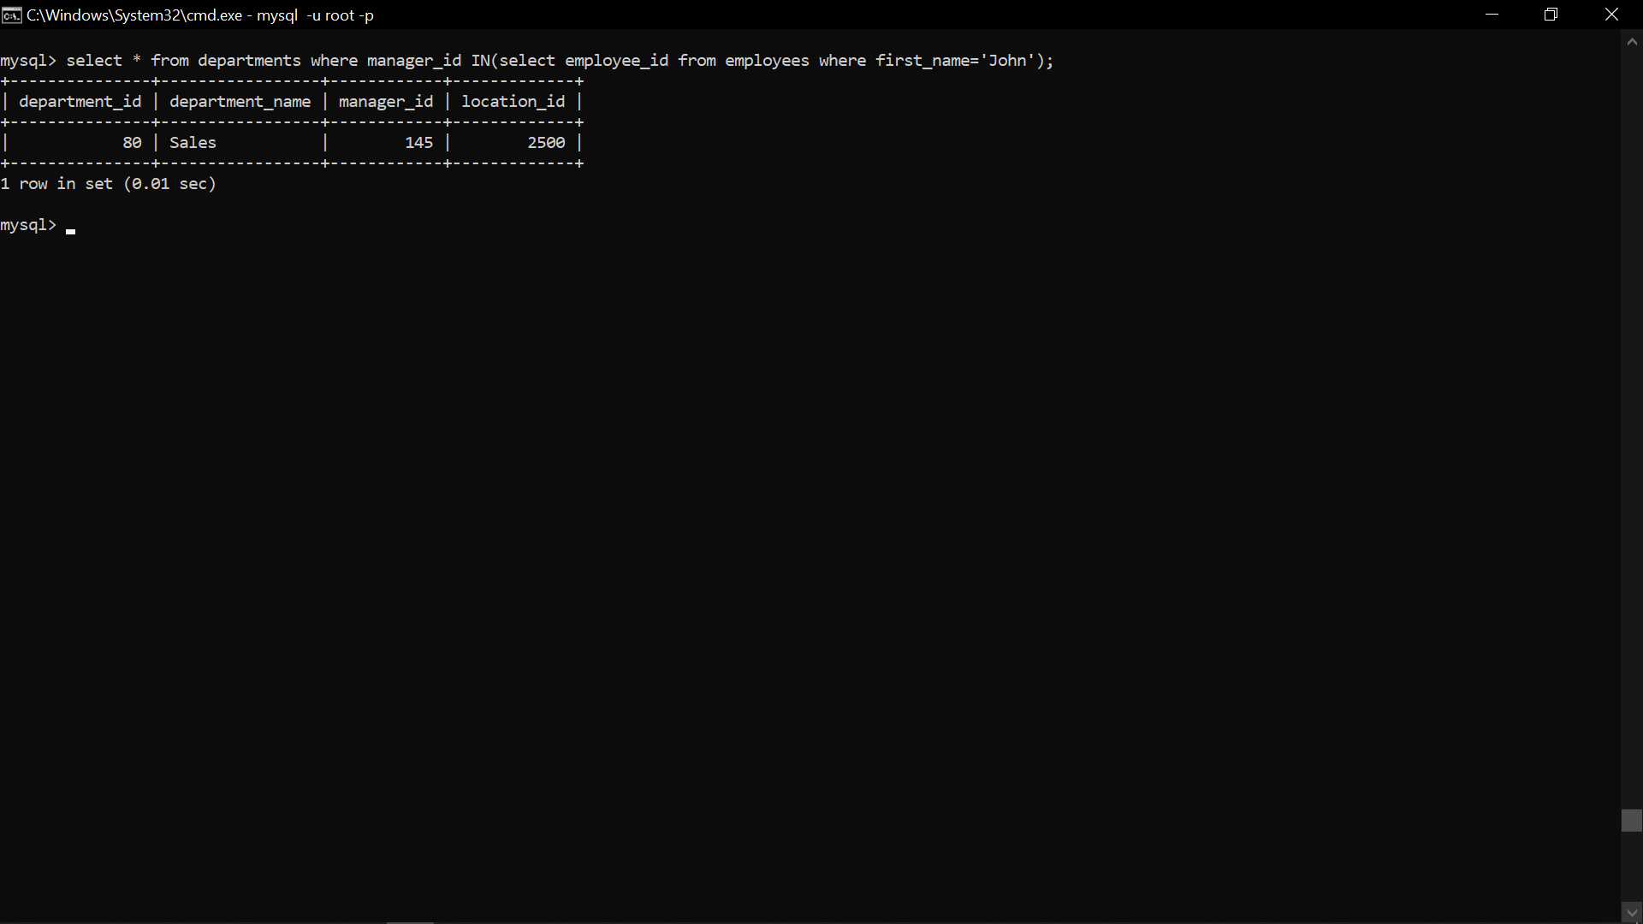

1. Display employees who did not do any job in the past.

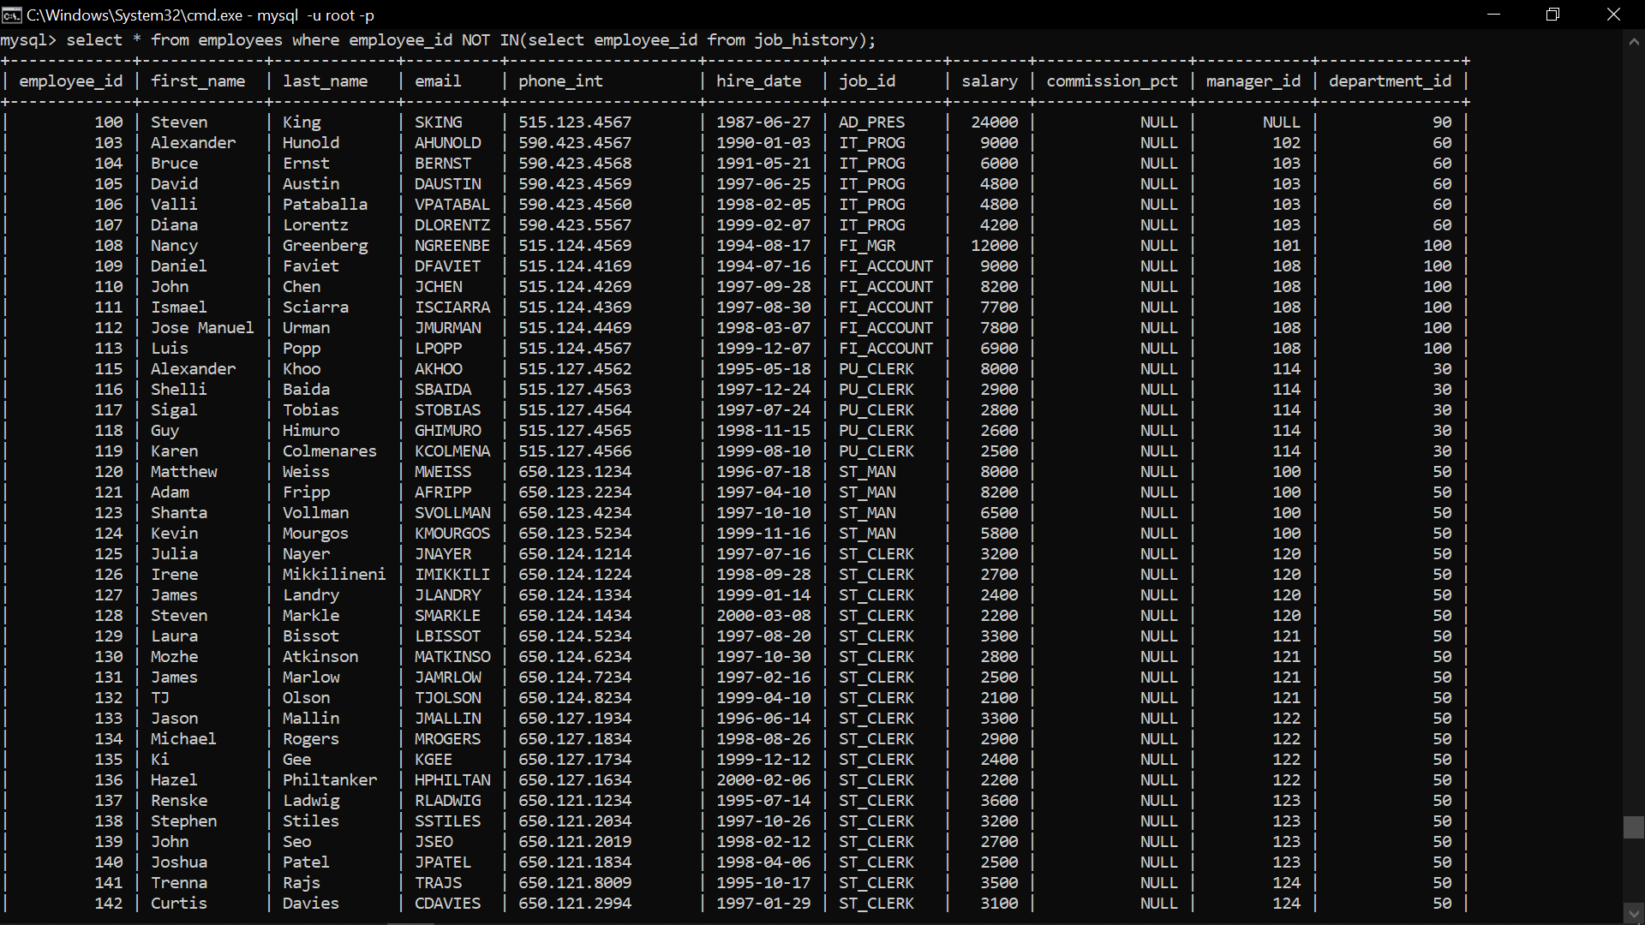

1. Display job title and average salary for employees who did a job in the past.

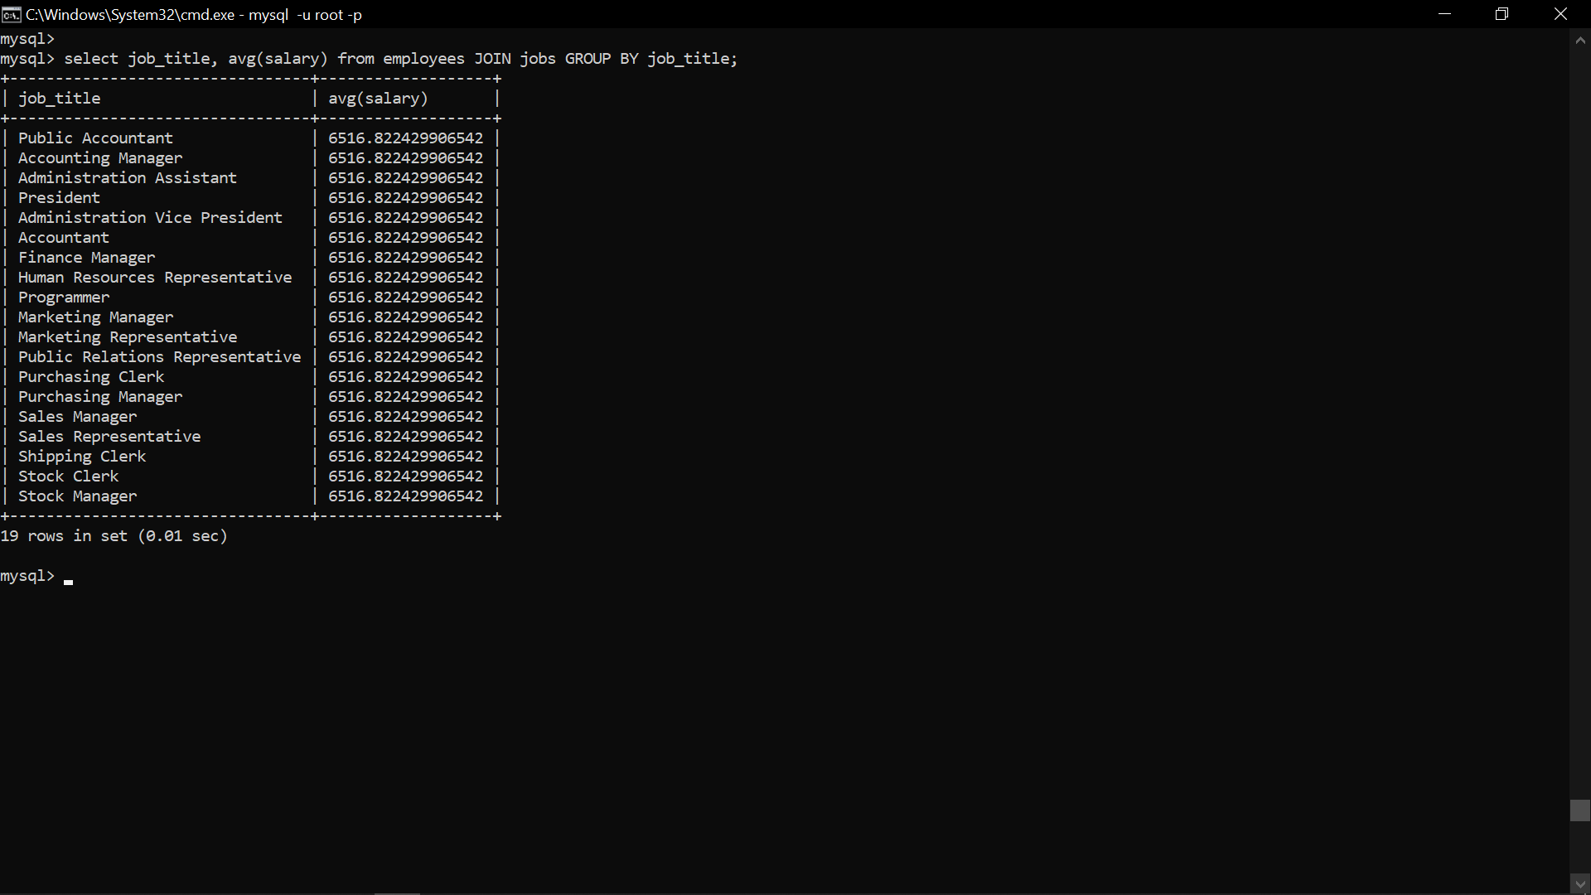

1. Display country name, city, and number of departments where department has more than 5 employees.

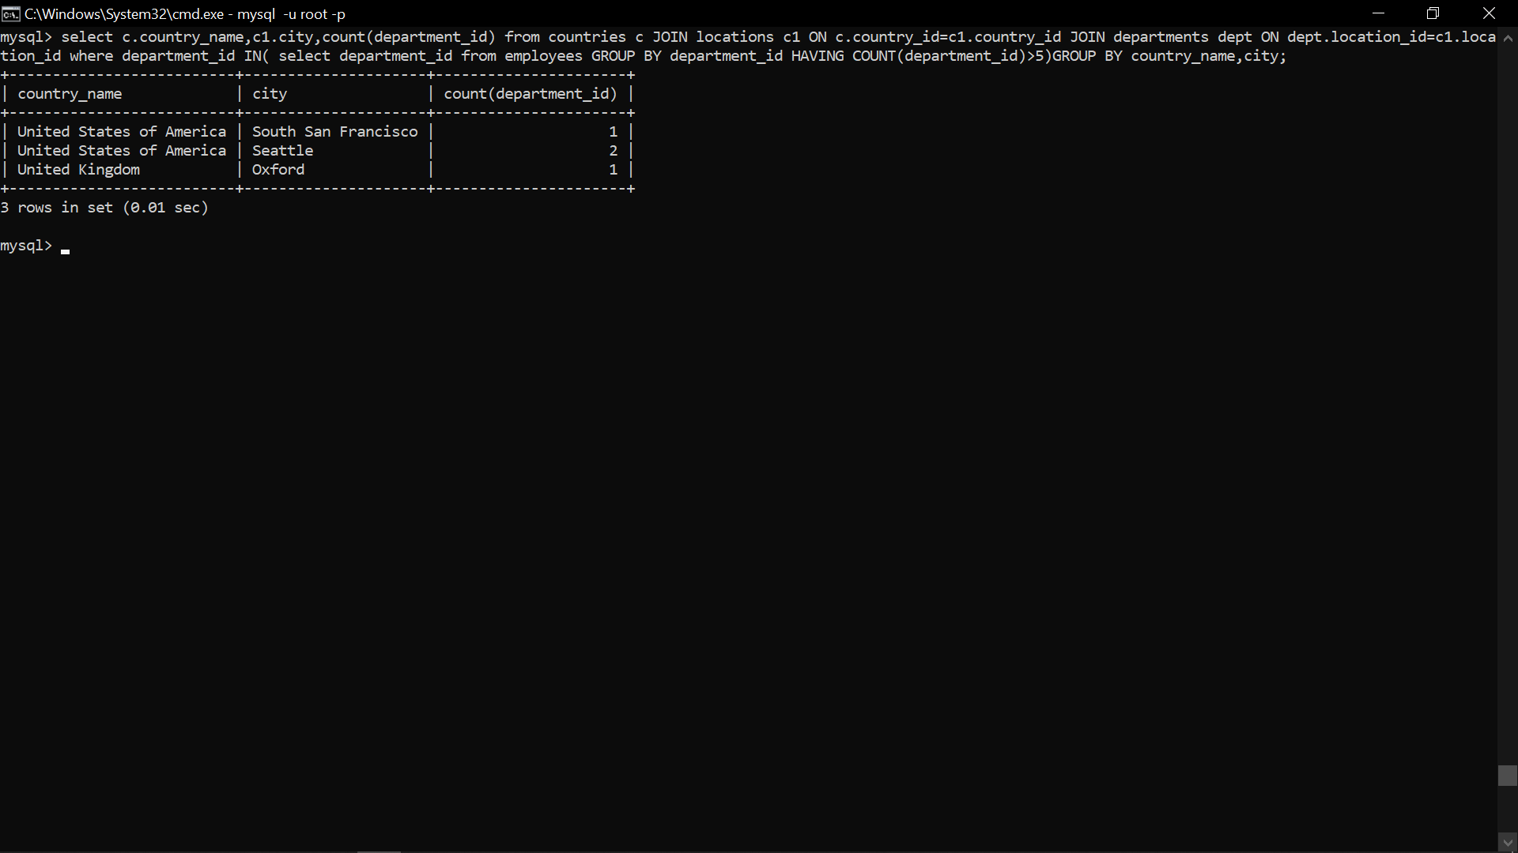

1. Display details of manager who manages more than 5 employees.

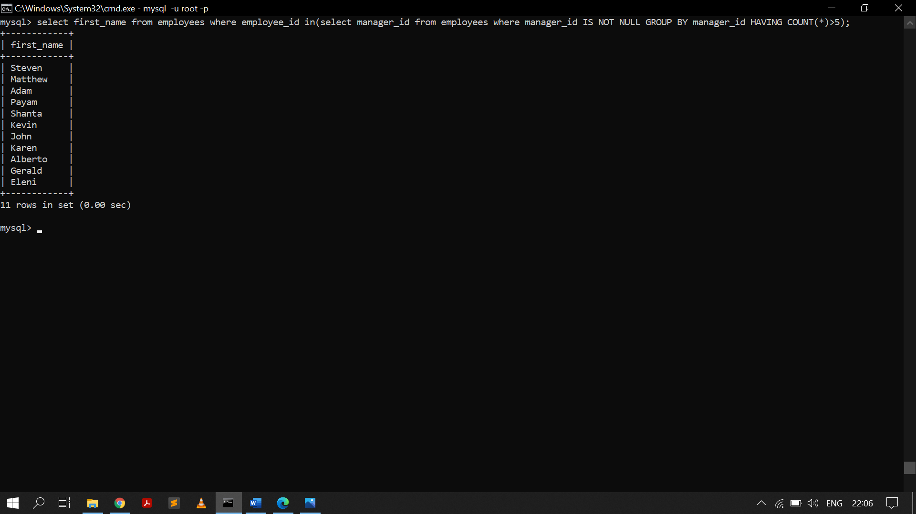

1. Display details of current job for employees who worked as IT Programmers in the past.

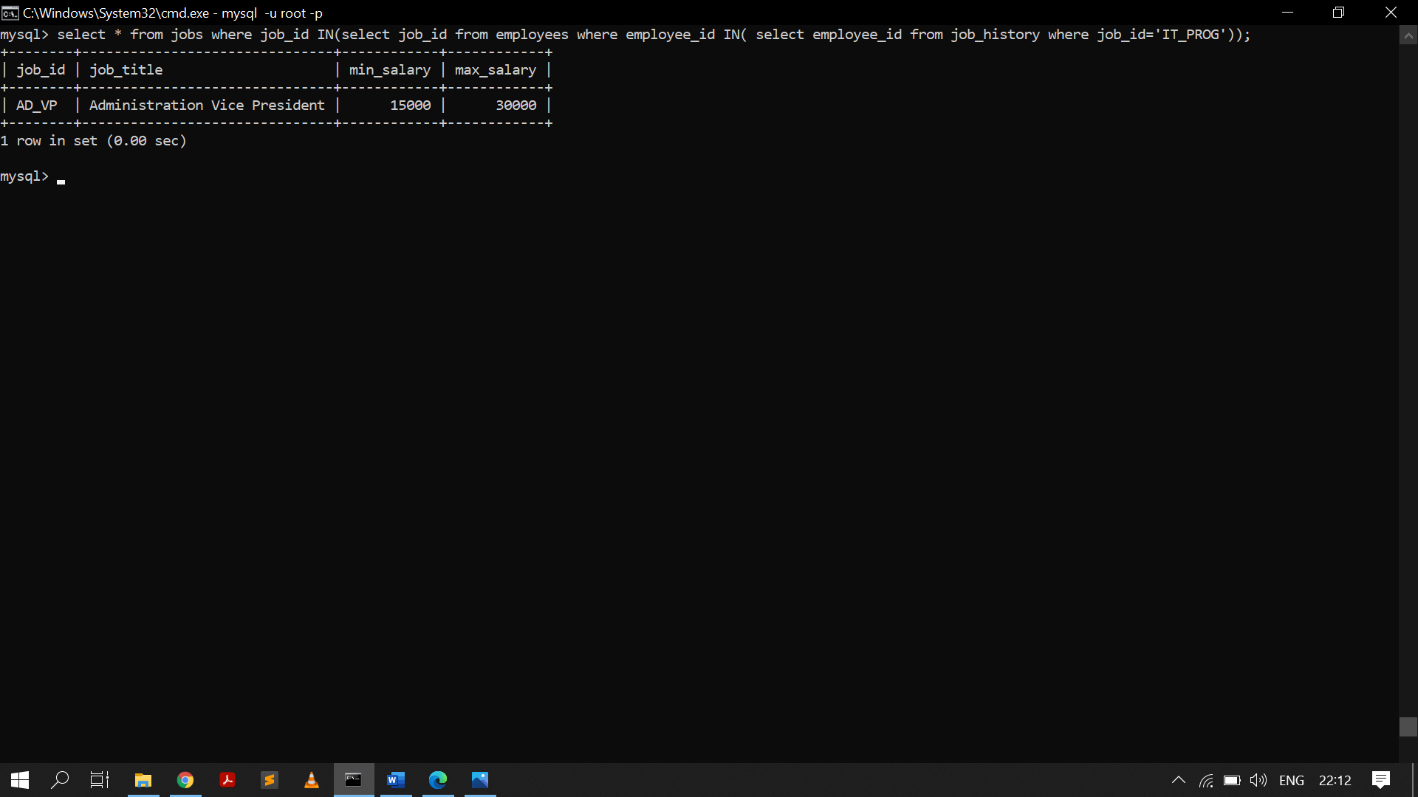

1. Display the details of employees drawing the highest salary in the department.

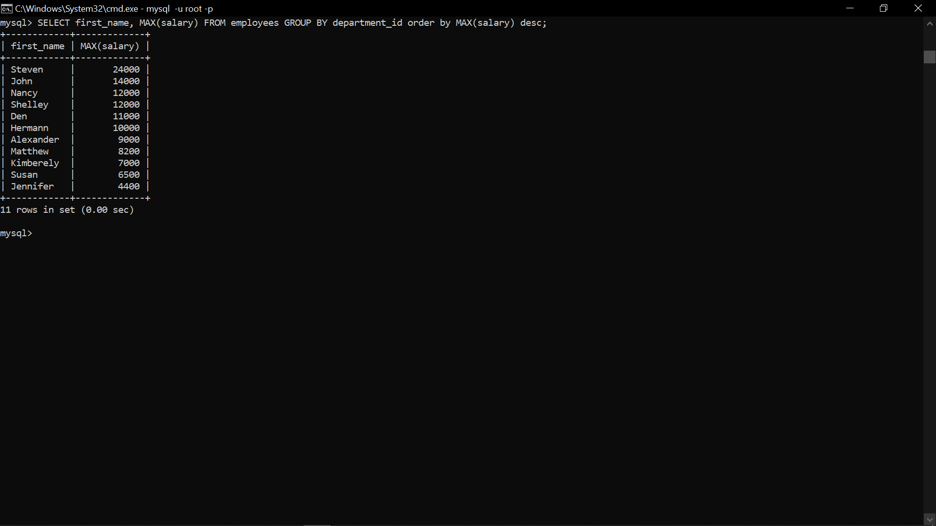

1. Display third highest salary of employees

